**Crontab:**

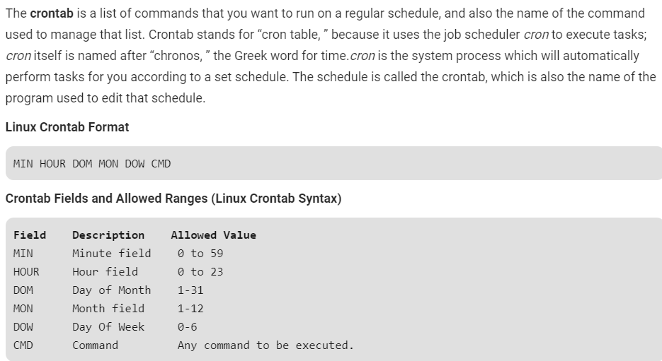

* Crontab -e 🡪 command to edit crontab file add an entry
* Crontab -l 🡪 to list the already scheduled jobs
* Crontab -u <username> -e 🡪 to edit the other user’s crontab
* Crontab -u <username> -l 🡪 to list the other user’s crontab

**Examples:**

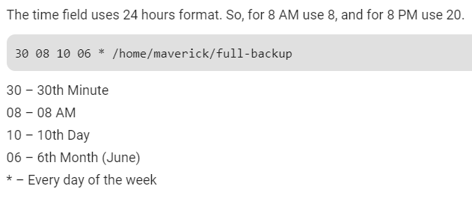

**To schedule a job more than one time:**

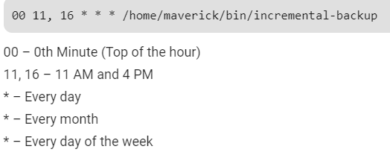

**To schedule a job for certain range of time:**

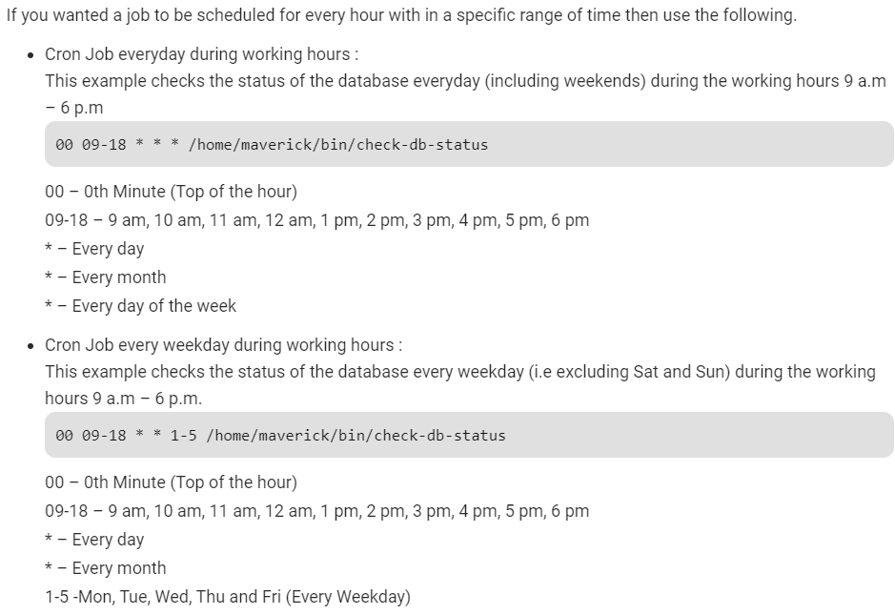

**To schedule a job for every 10 mins:**

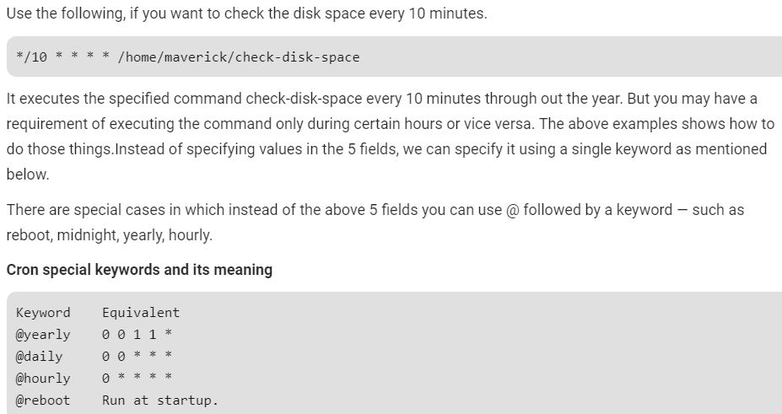

**Schedule for yearly, monthly, weekly, daily, hourly & reboot.**

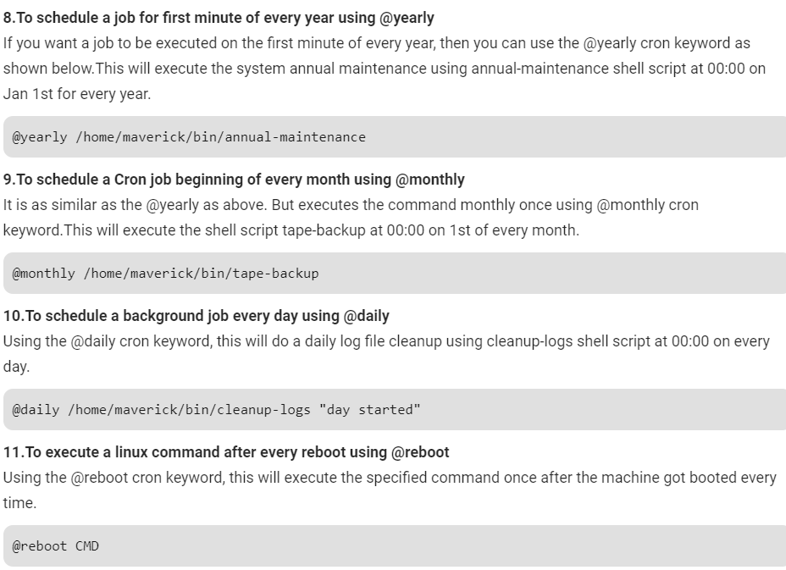

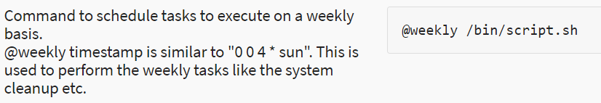

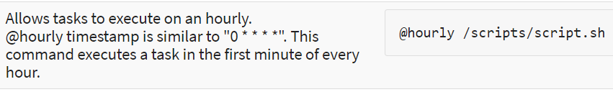

**Some more examples:**

